DISTANCE MEASUREMENT BY ULTRASONIC SENSOR

ABSTRACT

The project is designed to measure the distance of any object by using an ultrasonic transducer. Ultrasonic means of distance measurement is a convenient method compared to traditional one using measurement scales. This kind of measurement is particularly applicable to inaccessible areas where traditional means cannot be implemented such as high temperature, pressure zones etc.
This proposed system uses an ultrasonic module interfaced to a microcontroller of PIC family. An ultrasonic transducer comprising of a transmitter and receiver are used for the project. The transmitted waves are reflected back from the object and received by the transducer again. The total time taken from sending the waves to receiving it is calculated by taking into consideration the velocity of sound. Then the distance is calculated by a program running on the microcontroller and displayed on an LCD screen interfaced to the microcontroller. The ultrasonic sensor produces 40 kHz sound waves.
Further the project can be enhanced by using high frequency transducers to make is fit for medical applications like ultrasound machine.

BLOCK DIAGRAM:
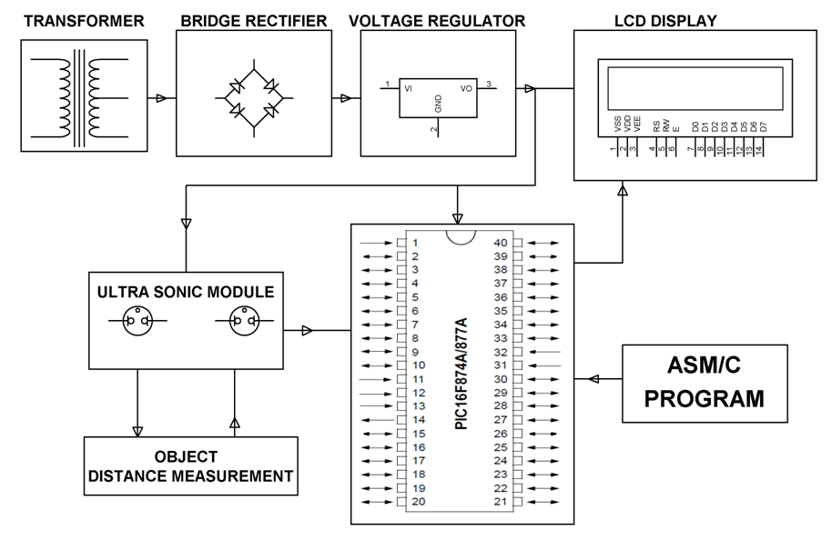

HARDWARE REQUIREMENTS:

PIC series Microcontroller, LCD, Transformer, Diodes, Bridge Rectifier, Voltage Regulator, Resistors, Capacitors, Ultrasonic Transducers.

SOFTWARE REQUIREMENTS:

HI-TECH PICC Tool suite
Language: Embedded C or Assembly.

